PPG & Survey Results Report

Patient Reference Group
The patient group comprises 46 members

Distribution Details
Attendance  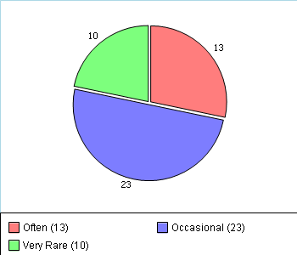 | Gender  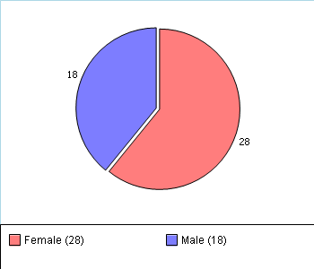
Ethnicity  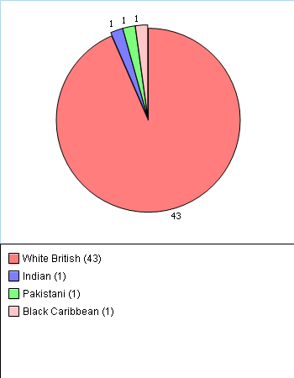 | Age  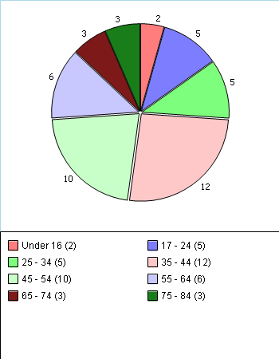

Survey Results

Woodstock Bower Patient Survey 2014
Number of Responses: 64
We would be grateful if you would complete this survey about your doctor and general practice. They want to provide the highest standard of care. A summary from this survey will be fed back to them to help them identify areas for improvement. Your opinions are very valuable. Please answer ALL the questions you can. There are no right or wrong answers and your doctor will NOT be able to identify your individual answers. Thank you.

About Your Visit to the GP

About Receptionists and Appointments
Q1 How helpful do you find the receptionists at your Woodstock Bower ?
Very helpful 68%
Fairly helpful 23%
Not very helpful 1%
Not at all helpful 4%
Don’t know 0%
No response 4%
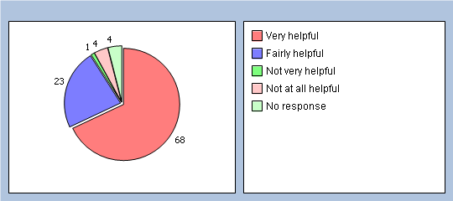
Q2 How easy is it to get through to someone at your Woodstock bower on the phone?
Very easy 20%
Fairly easy 51%
Not very easy 10%
Not at all easy 9%
Don’t know 0%
Haven’t tried 6%
No response 4%
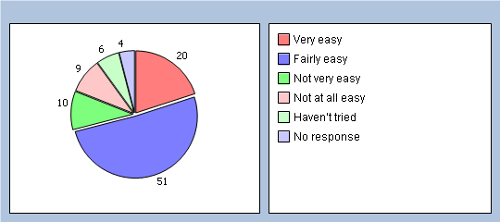
Q3 How easy is it to speak to a doctor or nurse on the phone ?
Very easy 12%
Fairly easy 32%
Not very easy 15%
Not at all easy 6%
Don’t know 4%
Haven’t tried 26%
No response 5%
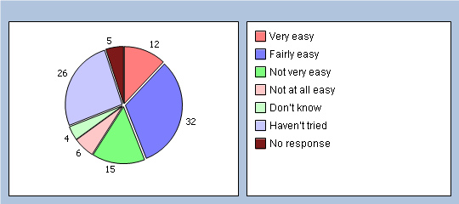
Q4 If you need to see a GP urgently, can you normally get seen on the same day?
Yes 64%
No 18%
Don’t know / never needed to 15%
No response 3%
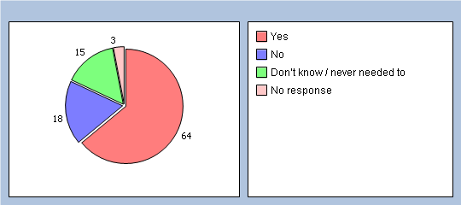
Q5 How easy is it to book an appointment ahead ?
Very easy 29%
Fairly easy 46%
Not very easy 12%
Not at all easy 7%
Don’t know 0%
Haven’t tried 0%
No response 6%
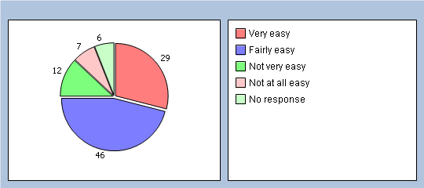

Thinking of times when you want to see a particular doctor:
Q6 How quickly do you usually get seen?
Same day or next day 14%
2-4 days 7%
5 days or more 43%
I don’t usually need to be seen quickly 18%
Don’t know, never tried 9%
No response 9%
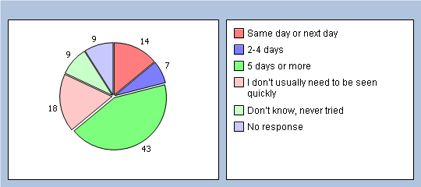
Q7 How do you rate how quickly you were seen?
Excellent 10%
Very good 26%
Good 18%
Satisfactory 9%
Poor 10%
Very poor 10%
Does not apply 6%
No response 11%
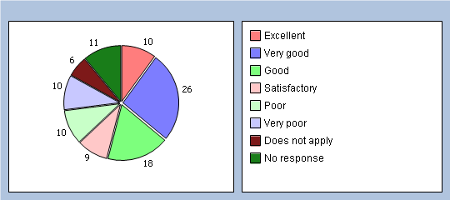

Thinking of times when you are willing to see any doctor:
Q8 How quickly do you usually get seen?
Same day or next day 32%
2-4 days 17%
5 days or more 25%
I don’t usually need to be seen quickly 9%
Don’t know, never tried 9%
No response 8%
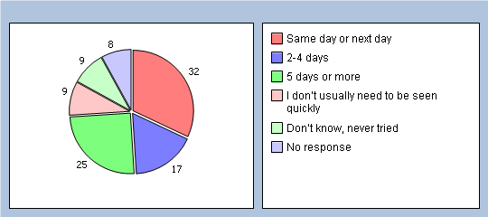
Q9 How do you rate how quickly you were seen?
Excellent 14%
Very good 31%
Good 15%
Satisfactory 15%
Poor 6%
Very poor 6%
Does not apply 7%
No response 6%
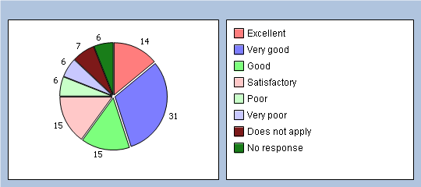

Thinking of your most recent consultation with a doctor or nurse
Q10 How long did you wait for your consultation to start?
Less than 5 minutes 14%
5 – 10 minutes 35%
11 – 20 minutes 17%
21 – 30 minutes 18%
More than 30 minutes 6%
There was no set time for my consultation 1%
No response 9%
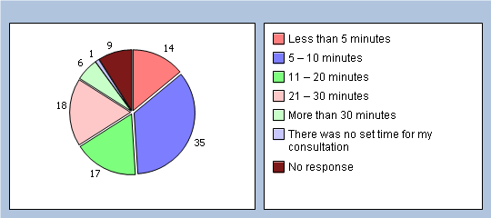
Q11 How do you rate how long you waited?
Excellent 25%
Very good 21%
Good 10%
Satisfactory 23%
Poor 7%
Very poor 6%
Does not apply 0%
No response 8%
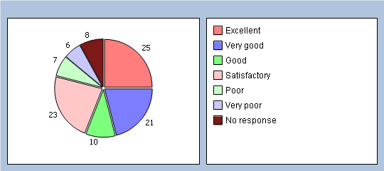
Q12 Is your GP practice currently open at times that are convenient to you?
Yes 68%
No 12%
Don’t know 4%
No response 16%
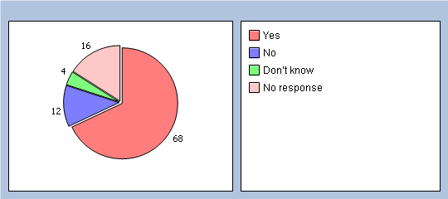
Q13 Which of the following additional opening hours would make it easier for you to see or speak to someone? (please X all boxes that apply)
Before 8am 37%
At lunchtime 14%
After 6.30pm 34%
On a Saturday 31%
On a Sunday 17%
None of these 15%
Q14 Is there a particular GP you usually prefer to see or speak to?
Yes 65%
No (Go to Q30) 31%
There is usually only one doctor in my surgery (Go to Q30) 0%
No response 4%
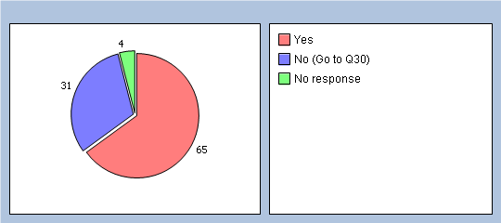
Q15 How often do you see or speak to the GP you prefer?
Always or almost always 21%
A lot of the time 29%
Some of the time 10%
Never or almost never 3%
Not tried at this GP practice 3%
No response 34%
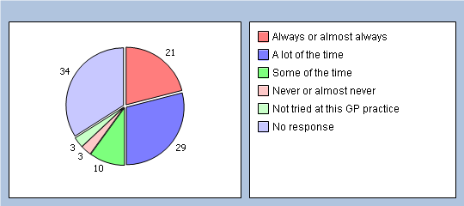

If you haven’t seen a nurse in the last 6 months please go to Q37. How good was the Nurse you last saw at:
Q16 Putting you at ease?
Very good 50%
Good 14%
Satisfactory 0%
Poor 1%
Very poor 1%
Does not apply 0%
No response 34%
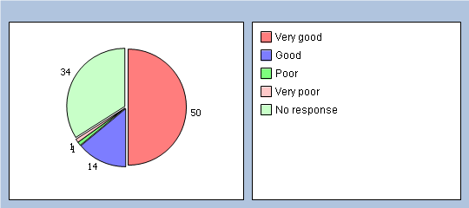
Q17 Giving you enough time?
Very good 50%
Good 12%
Satisfactory 3%
Poor 0%
Very poor 1%
Does not apply 0%
No response 34%
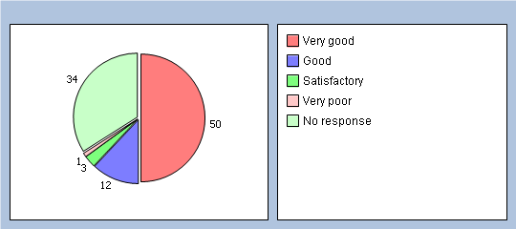
Q18 Listening to you?
Very good 51%
Good 9%
Satisfactory 3%
Poor 0%
Very poor 1%
Does not apply 0%
No response 36%
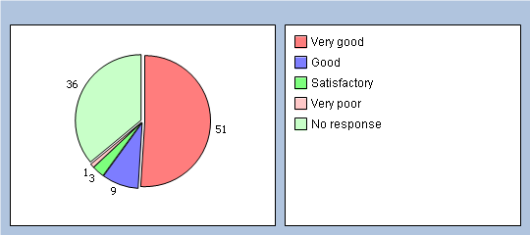
Q19 Explaining your condition and treatment?
Very good 40%
Good 15%
Satisfactory 4%
Poor 0%
Very poor 3%
Does not apply 3%
No response 35%
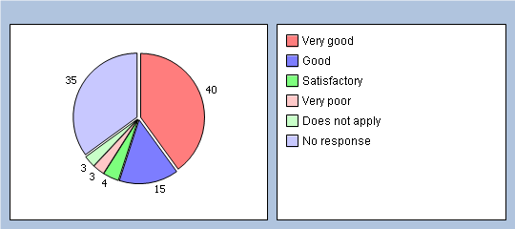
Q20 Involving you in decisions about your care?
Very good 32%
Good 14%
Satisfactory 1%
Poor 1%
Very poor 1%
Does not apply 7%
No response 44%
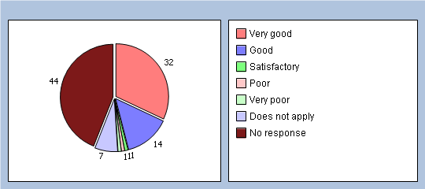
Q21 Providing or arranging treatment for you?
Very good 35%
Good 17%
Satisfactory 1%
Poor 0%
Very poor 1%
Does not apply 7%
No response 39%
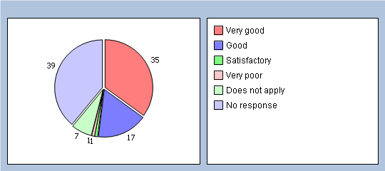
Q22 Would you be completely happy to see this nurse again?
Yes 53%
No 0%
No response 47%
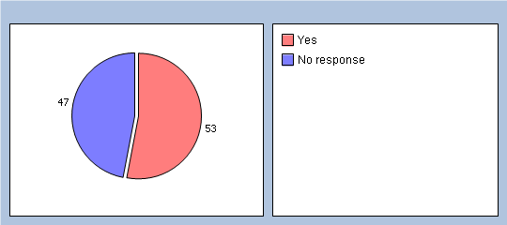

Thinking about the care you get from your doctors and nurses overall, how well does the practice help you to:
Q23 Understand your health problems?
Very well 54%
Unsure 9%
Not very well 4%
Does not apply 3%
No response 30%
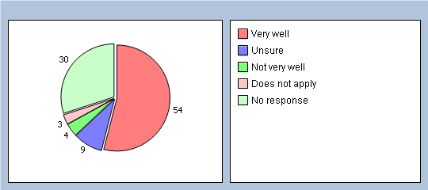
Q24 Cope with your health problems
Very well 50%
Unsure 14%
Not very well 4%
Does not apply 1%
No response 31%
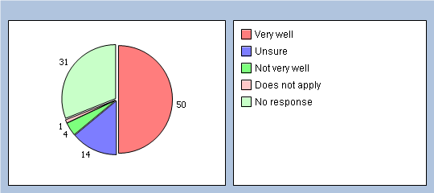
Q25 Keep yourself healthy
Very well 40%
Unsure 14%
Not very well 3%
Does not apply 3%
No response 40%
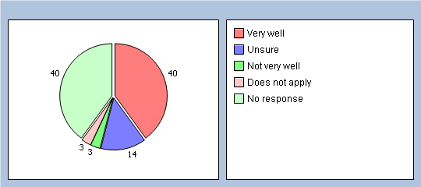
Q26 Overall, how would you describe your experience of your GP surgery?
Excellent 21%
Very good 28%
Good 10%
Satisfactory 7%
Poor 1%
Very poor 0%
No response 33%
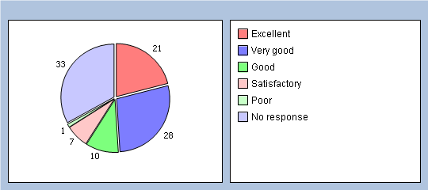
Q27 Would you recommend your GP surgery to someone who has just moved to your local area?
Yes, definitely 34%
Yes, probably 26%
No, probably not 1%
No, definitely not 6%
Don’t know 0%
No response 33%
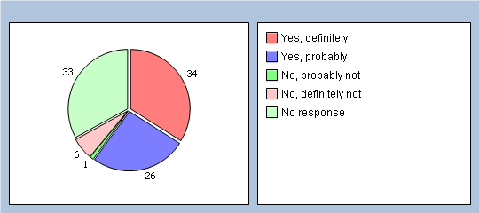

It will help us to understand your answers if you could tell us a little about yourself
Q28 Are you ?
Male 40%
Female 35%
No response 25%
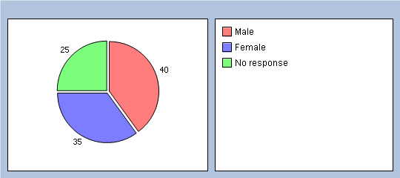
Q29 How old are you?
Under 16 1%
16 to 44 12%
45 to 64 29%
65 to 74 21%
75 or over 10%
No response 27%
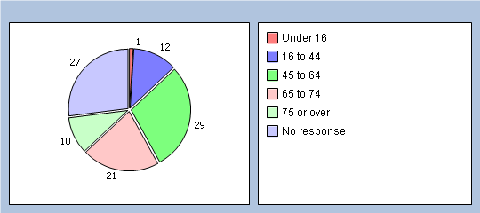
Q30 Do you have a long-standing health condition?
Yes 57%
No 29%
Don’t know / can’t say 6%
No response 8%
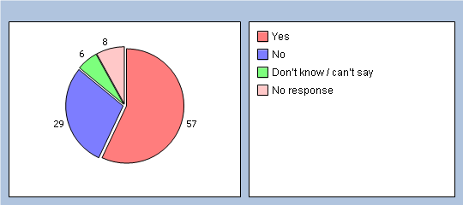
Q31 What is your ethnic group?
White 87%
Black or Black British 0%
Asian or Asian British 3%
Mixed 1%
Chinese 0%
Other ethnic group 1%
No response 8%
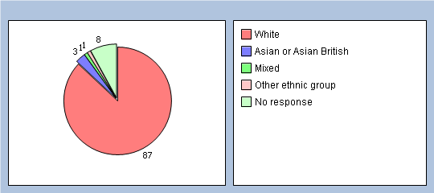
Q32 Which of the following best describes you?
Employed (full or part time, including self-employed) 45%
Unemployed / looking for work 3%
At school or in full time education 1%
Unable to work due to long term sickness 7%
Looking after your home/family 3%
Retired from paid work 29%
Other 1%
No response 11%
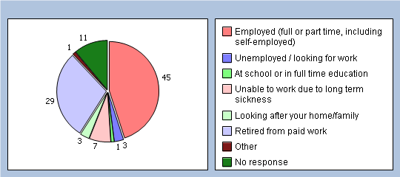
Finally, please add any other comments you would like to make about your GP practice:
Parking is bad for disabled People particularly whilst the extension is being built

